CPU Scheduling

Balite, Marie Edcel D.1, de Jesus, Nikka Marie C.2

***Abstract*— In this paper, the different CPU scheduling algorithms will be discussed one by one, followed by sample test cases used accordingly. Each test case will be acquired randomly.**

***Keywords***—  **First-Come-First-Serve scheduling; Shortest Job First scheduling; Shortest Remaining Time First; Non-preemptive Priority scheduling; Preemptive Priority scheduling; Round Robin scheduling**

1. Introduction

CPU scheduling is the basis for multiprogrammed operating systems. It deals with the problem to which process the CPU should be allocated. There are many scheduling algorithms which can be used in scheduling the processes. By switching the CPU among processes, the operating system can make the computer more productive.

1. Scheduling Algorithms

Scheduling algorithms are divided into two categories: Preemptive and Non-preemptive.

*Note: The two scheduling categories do not necessarily mean they are the same with Preemptive Priority Scheduling Algorithm and Non-preemptive Priority Scheduling Algorithm.*

In non-preemptive scheduling, once the CPU has been allocated to a process, the CPU is kept by the process until it is released either by terminating or by switching to a waiting state.

In preemptive scheduling on the other hand, the processes are usually assigned with priorities. When a process with a higher priority arrives during the execution of another process, the execution will be interrupted for some time and will be resumed later when the priority task has finished its execution.

1. *First-Come- First- Serve (FCFS) Scheduling*

As the name suggests, in this scheduling algorithm, the process which arrives first, gets the CPU allocated first.

Sample test case #1:

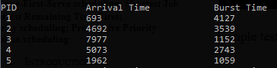

Sample test case#2:

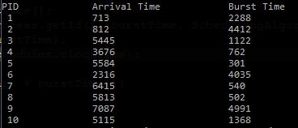

Sample test case #3:

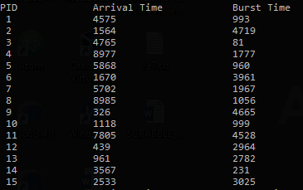

1. *Shortest Job First (SJF) Scheduling*

Basically, the idea behind this algorithm is that the process which has the smallest amount of burst time will be executed first. SJF is of two types: Non-preemptive and Preemptive, although SJF is usually referred to as the non-preemptive type, while the preemptive one is commonly known as the SRTF or Shortest Remaining Time First.

Sample test case #1:

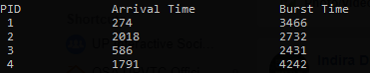

Sample test case #2:

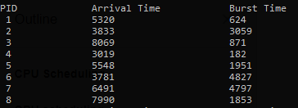

Sample test case #3:

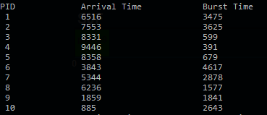

1. *Shortest Remaining Time First (SRTF) Scheduling*

SRTF scheduling is basically the preemptive type of SJF. This means that when a process with a shorter or smaller amount of burst time arrives during the execution of a longer process, the execution will be interrupted for some time and will be resumed later when the priority task has finished its execution.

Sample test case #1:

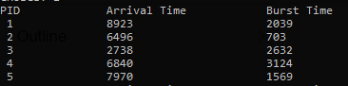

Sample test case #2:

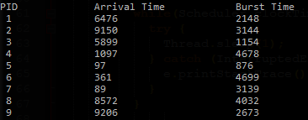

Sample test case #3:

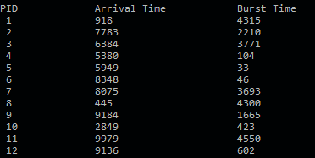

1. *Non-preemptive Priority Scheduling*

In non-preemptive priority algorithm, processes are executed based on their assigned priorities, but with respect of course to their arrival time.

Sample test case #1:

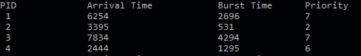

Sample test case #2:

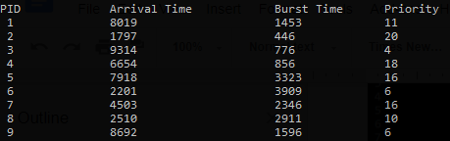

Sample test case #3:

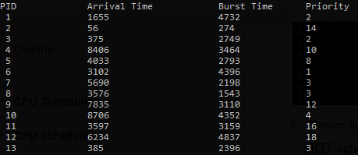

1. *Preemptive Priority Scheduling*

As stated above, processes with higher priority are executed first. If it happens that a process is being executed then another process with a higher priority arrives, its execution will be interrupted, and will then be resumed after the task has finished its execution.

Sample test case #1:

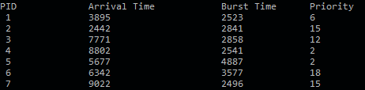

Sample test case #2:

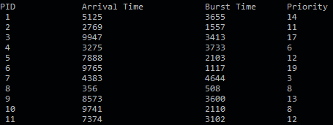

Sample test case #3:

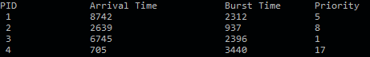

1. *Round Robin (RR) Scheduling*

Round robin scheduling is the preemptive type of First-Come First-Served scheduling. The processes are dispatched in a first-in first-out manner, but each of them is only allowed to execute for only a limited of time. The limits assigned to each process is called the time quantum.

If the process finishes before the time quantum expires, it is swapped out of the CPU just like the normal FCFS algorithm.

If the time quantum expires first, the process is swapped out and moved to the back end of the queue.

The queue is maintained in a circular manner so that when all processes have had a turn, the first process is given another turn, and so on.

Sample test case #1:

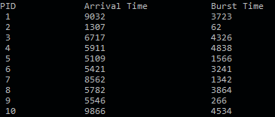

Sample test case #2:

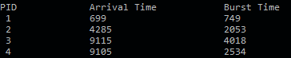

Sample test case #3:

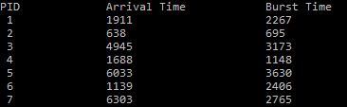

References

1. Studytonight, 2018. What is CPU Scheduling? Retrieved April 20, 2018, from https://www.studytonight.com/operating-system/cpu-scheduling
2. CPU Scheduling. Retrieved April 20, 2018, from https://www.cs.uic.edu/~jbell/CourseNotes/OperatingSystems/5_CPU_Scheduling.html
3. Romero, V.M., 2018, CPU Scheduling.